**ASSIGNMENT 11.1**

**PROBLEM STATEMENT:**

* What is the total amount of petrol in volume sold by every distributor?
* Which are the top 10 distributors ID's for selling petrol? Also display the amount of petrol sold in volume.
* List 10 years where consumption of petrol is more with the distributer id who sold it.
* Find the distributer name who sold petrol in least amount.

**INPUT (DATA SET):**

The data set can be downloaded from the following link

<https://github.com/prateekATacadgild/mAPrEDuce/commit/7f78340c5d59d22940587bb76bec94dd4781265f>

**DATA SET DESCRIPTION:**

Column 1: District ID I4N1M1 varchar

Column 2: Distributor name shell varchar

Column 3: Buy rate (million) $957.70 varchar

Column 4: Sell rate (million) $5779.92 varchar

Column 5: volume IN (million cubic liter) 933, int

Column 6: volume OUT (million cubic liter) 843, int

Column 7: Year 1624 int

**PROGRAM:**

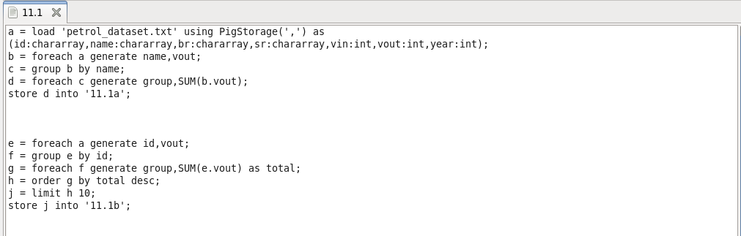

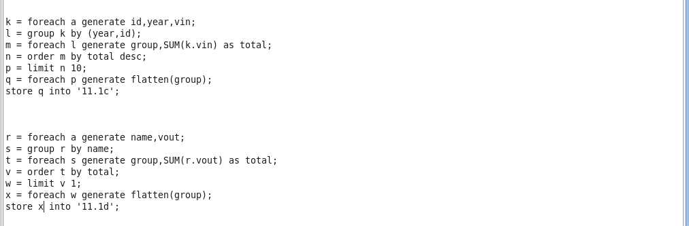

**OUTPUT:**

